17.45: a)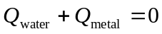
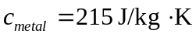

b) Water has a larger specific heat capacity so stores more heat per degree of temperature change.

c) If some heat went into the styrofoam then 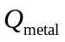 should actually be larger than in part (a), so the true 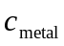is larger than we calculated; the value we calculated would be smaller than the true value.

